
To
SCHOOL TIMETABLE
 | MONDAY | TUESDAY | __________ | FRIDAY
0
Care Class
1
2
3
4

UNIT 3 PLANNER
WEEK | MON | TUES | WED | THUR | FRI | SAT | SUN
1(5)
2(6)
3(7)
4(8)
Christmas Holidays
5(1)
6(2)
7(3)
8(4)
9(5)
10(6)
11(7)
12(8)
13(9)
14(10)
Easter Holidays
15(1)
16(2)
17(3)
18(4)
19(5)
20(6)

STUDENT PLANNER
Year 12 Unit 3

To achieve their full potential, students studying:
- General/ATAR subjects should complete 2 hours of homework/study per night
- NON ATAR subjects should complete 1-1.5 hours of homework/study per night
WEEKLY HOME STUDY PLANNER
 | MONDAY | TUESDAY | _________ | FRIDAY |  | FLEXIBLE LEARNING DAY | SATURDAY | SUNDAY
MORNING |  |  |  |  | 8-9
SCHOOL |  |  |  |  | 9-10
3:30-4 |  |  |  |  | 10-11
4-4:30 |  |  |  |  | 11-12
4:30-5 |  |  |  |  | 12-1
5-5:30 |  |  |  |  | 1-2
5:30-6 |  |  |  |  | 2-3
6-6:30 |  |  |  |  | 3-4
6:30-7 |  |  |  |  | 4-5
7-7:30 |  |  |  |  | 5-6
7:30-8 |  |  |  |  | 6-7
8-8:30 |  |  |  |  | 7-8
8:30-9 |  |  |  |  | 8-9

HOLIDAY PLANNER – list tasks to complete or subjects to focus on….

MAROOCHYDORE STATE HIGH SCHOOL P.O.BOX 55, 160 MAROOCHYDORE ROAD, MAROOCHYDORE, QLD 4558 TEL: (07) 5409 7333 ABSENCE LINE: (07) 5409 7360 WEB: www.maroochydoreshs.eq.edu.au
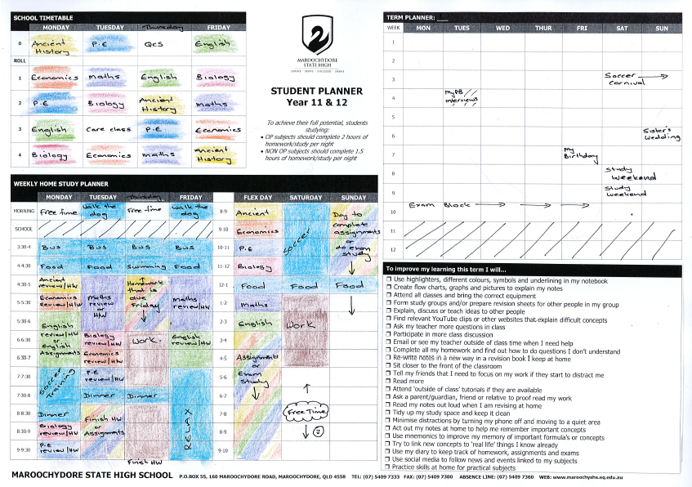
How to
To improve my learning in this unit, I will…
❒ Use highlighters, different colours, symbols and underlining in my notebook
❒ Create flow charts, graphs and pictures to explain my notes
❒ Attend all classes and bring the correct equipment
❒ Form study groups and/or prepare revision sheets for other people in my group
❒ Explain, discuss or teach ideas to other people
❒ Find relevant YouTube clips or other websites that explain difficult concepts
❒ Ask my teacher more questions in class
❒ Participate in more class discussion
❒ Email or see my teacher outside of class time when I need help
❒ Complete all my homework and find out how to do questions I don’t understand
❒ Re-write notes in a new way in a revision book I keep at home
❒ Sit closer to the front of the classroom
❒ Tell my friends that I need to focus on my work if they start to distract me
❒ Read more
❒ Attend ‘outside of class’ tutorials if they are available
❒ Ask a parent/guardian, friend or relative to proof read my work
❒ Read my notes out loud when I am revising at home
❒ Tidy up my study space and keep it clean
❒ Minimise distractions by turning my phone off and moving to a quiet area
❒ Act out my notes at home to help me remember important concepts
❒ Use mnemonics to improve my memory of important formula’s or concepts
❒ Try to link new concepts to ‘real life’ things I know already
❒ Use my diary to keep track of homework, assignments and exams
❒ Use social media to follow news and events linked to my subjects
❒ Practice skills at home for practical subjects

How to create a Study Planner
- School Timetable
Write in your timetable. Colour code your subjects
- Weekly Home Study Planner
Write in your regular activities in the correct time slots. For example;
- Catching the bus
- Afternoon tea (food)
- Work shifts. Even if work shifts change, you should be able to guess how many hours per week you
- Sports/cultural activities
- Add ½ hour of review or homework (H/W) time for all subjects that you study on each day.
For example if you have English on a Monday, you should make time Monday afternoon to either review your English work from Monday’s lesson and/or complete English homework
- Add some general assignment or exam study times.
It is difficult to manage your work ‘flow’ for each subject as they get busy at different times. By building in some ‘general assignment time’, you know that you have scheduled extra time to cope with the increased work load
- Be realistic.
If you know that you MUST watch a particular show or that you never do work on a Friday night then don’t schedule study time then.
- Complete the Unit Planner.
Add dates to your calendar that will change your routine for that week. By doing this you will be able to plan to get extra work done before the event, rather than handing an assignment in late because you were disorganised
- What extra things could you do to improve your learning?
Tick at least three strategies that you will genuinely try to do this term to improve your learning

Be realistic
Add events to the Term Planner
Reflect on your MyPB goals to choose learning strategies that will help you to be successful at school this term
Even if you don’t have homework you should schedule time to review work covered during the day
HOLIDAY PLANNER – list tasks to complete or subjects to focus on….
English Math Ancient Business Cert II Hospitality

Practice writing Practice tasks Do revision sheet Find case study Revise booklets
paragraphs from text book examples


Revise notes and go over revision sheets
Create a study planner
Answer questions from text book
Study Ideas

